Assignment 5
Due Date: 30 October 2012

NOTE: This assignment is to be done in groups which will be announced during class.

Background

Evolutionary Robotics (ER) is an extension of the basic Evolutionary Algorithm (EA) to the domain of robotics. Typically the ER process is used to automate the development of optimized and accurate robotic controllers, since ER removes the need for manual coding of robotic controllers by a human.

The controller used by a robot allows the robot to perform a certain action. A robotic controller typically produces appropriate motor movements which will allow a robot to perform its task accurately.

A simple version of the ER process would look as follows:

initialize a random population of candidate controllers
while stopping condition(s) not true do
evaluate the fitness of each controller in the population
perform crossover and mutation to create offspring controllers
select the new population
end while
output the best evolved controller in the final population

Algorithm 1: The ER Process

As can be seen from Algorithm 1, the ER process is identical to the basic EA. However, certain considerations have to be made when implementing an ER process:

- Encoding used to represent candidate controllers in the population
  - for simple robotic tasks (such as the one to be evolved in this assignment), array type structures can be used to encode controllers
- The fitness evaluation process of each controller
  - as in the basic EA, a fitness function is typically employed in order to measure the performance of each controller in the population. This fitness function often depends on physical quantities that can be measured in the robot’s environment, e.g. the position of the robot at a given point in time

Use is often made of robotic simulators during the ER process. This is because measuring the physical quantities needed to calculate the fitness value for each controller in the real world can be very time consuming. If we can thus simulate these quantities, the ER process can be performed completely in software and is much faster.

Assignment

In order to explore the ER process, you are required to evolve one or more robotic controllers for a simple robot. This is to be done using the provided robotic simulator which will shortly be outlined. This simulator is programmed to operate in Java.

The robot on which the simulator is based, is a Lego Mindstorms NXT robot used for research in the Department of Computing Sciences. This robot makes use of differential steering to move, which is the same as is present, for example, on a wheel chair. The robot has two wheels which are controlled by two independent motors. Examples of motion for this robot are:

- If both motors turn forward at the same speed, the robot will move forward in a straight line.
- If both motors turn backward at the same speed, the robot will move backward in a straight line.
- If the motors turn in opposite directions at the same speed, the robot will turn on the spot.

The simulator for this robot assumes that the robot moves in discrete time periods of 400ms. Given the robot’s initial position and orientation, the motor speeds for each motor and the amount of 400ms periods that the robot maintains each of these pairs of speeds, the simulator will predict a path followed by the robot.

Implementation of Robotic Simulator

You will be supplied with a Java .jar file called MotionSimulator.jar. This file contains the following classes and methods which are applicable to this project. Please do not attempt to access any other classes directly, as these listed here are the only ones needed for this assignment.

//class describing the state of the robot at a given point in time.
//x and y are the robot’s position and a is its orientation angle
//units: x and y in cm and a in degrees
public class State
{
double x, y, a;

public State (double xin, double yin, double ain)
{
x = xin;
y = yin;
a = ain;
}
}

//class describing a certain motor command given to the robot
//left and right are the motor speeds given to either of the robots wheels. A positive value for either of //these speeds represents forward motion of the wheel, 0 represents a stationary wheel and a negative //value represents backward motion.
//NB: for the simulator to work properly it is assumed that each motor speed is an integer value in range
//[-700 700]
public class Command
{
int left, right;

public Command (int lin, int rin)
{
left = lin;
right = rin;
}
}

//class describing a command maintained by the robot for a certain amount of 400ms time intervals
//c is the command maintained and time is the number of 400ms periods this command is maintained //for. Therefore time > 0.
public class TimedCommand
{
Command c;
int time;

public TimedCommand (Command cin, int tin)
{
c = cin;
time = tin;
}
}

//class describing the robotic simulator as a whole. This is the most important class for usage in this //assignment
public class MotionSimulator
{
//default constructor for the simulator
public MotionSimulator() {}

//this method is where the actual simulation occurs
//INPUTS: initial is the state of the robot before it receives the commands contained in coms. //It is assumed that the robot will begin from rest before receiving the commands. coms is an //ArrayList containing one or more TimedCommands which are given to the robot in the order //they appear in this ArrayList
//OUTPUT: An ArrayList containing the predicted path that the robot will follow when given the //commands in coms. This ArrayList includes the initial state of the robot and all subsequent //states for each 400ms of motion
public ArrayList<State> getPath (State initial, ArrayList<TimedCommand> coms)
}

//class that can be used to visualize a path followed by the robot
public class VisualFrame
{
//constructor for VisualFrame class. The rendering of the path followed also takes place in this //constructor.
//INPUT: An ArrayList of States describing a path taken by the robot
//RENDERING: When a VisualFrame class is constructed with a given path, it will present a //window animating said path
public VisualFrame(ArrayList<State> path)
}

Note that in the above description, it is assumed that a global set of axes, namely the x-axis and y-axis are defined. The robot therefore moves in the xy-plane. The position and orientation of the robot are then defined as shown in Figure 1:

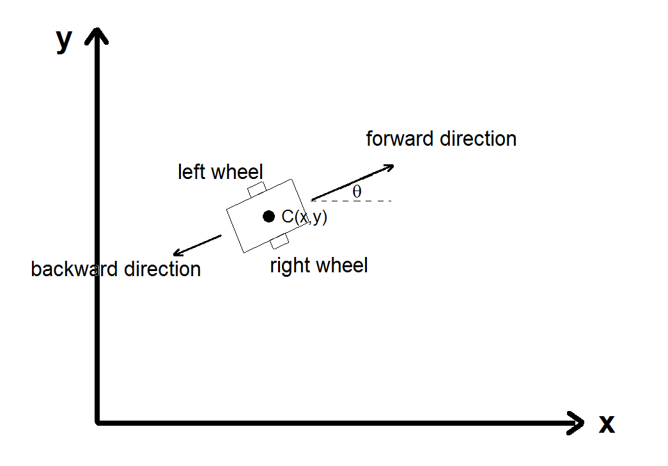
Figure 1: Simulator definitions

The x and y coordinate of the robot are actually the x and y coordinate of the centre point of the robot in the defined coordinate frame, C(x,y). The orientation angle θ of the robot is the angle that a forward-pointing vector makes with the x-axis. For example a robot moving in a straight line in the direction of the positive x-axis will have a constant orientation angle of zero, one moving in the direction of the negative y-axis will have orientation angle 270 degrees etc.

Task

Your group’s task is as follows:

- Decide on one or more controllers that can be evolved for the robot using the provided simulator. A simple example of such a controller is described in the next section. You are not limited to only evolving this controller (or evolving it at all). If you can come up with other ideas, you are welcome to rather evolve such controllers.

Example Controller to be Evolved

A simple controller to be evolved is one that will allow the robot to follow a predefined path, for example, a figure S. It is worth noting that the surface on which this robot is usually used has dimensions 2.76m by 1.84m. It is thus suggested that you have your S not too small (since the robot will perform suboptimally if small motions have to be made), but also not so large that the robot might fall off the working surface. An example could be as shown in Figure 2:

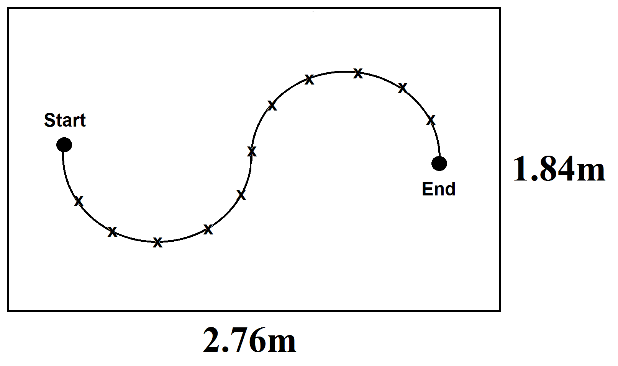
Figure 2: Example problem

In the above picture, the working surface of the robot is shown, as well as a figure S. The robot is thus required to get from the start point to the end point while following the path between these two points as closely as possible.

Chromosome encoding:

Encode the motor speeds and number of 400ms periods for each pair of these speeds to be used by the robot to perform above task as well as possible.

You should firstly decide on the encoding scheme to be used to encode these values, e.g. an array type structure or otherwise. You should also remember that above task can be done with various different combinations of motor speeds and times for each, i.e. there are various different solutions. Therefore, investigate variable length chromosomes to encode different quantities of commands, i.e. each chromosome in your population will not encode the same amount of commands. NB: Even if you do not evolve the controller suggested here, it is a requirement of this assignment that you investigate variable length chromosomes.

Fitness function:

The path produced by the commands encoded in each chromosome in the population can be obtained by making use of the simulator provided. By comparing this path with the ideal path in Figure 2, a fitness value can be assigned to a given chromosome based on how closely the path produced by the commands encoded in that chromosome resembles the ideal path. A specific function to do this will not be given here. Discuss in your group and decide on a suitable fitness function.

Mutation and Crossover:

Since all chromosomes in the population will not have the same length, you will not be able to use standard mutation and crossover operators. Discuss in your group and come up with variations of existing operators which can be applied to variable length chromosomes.

Stopping criteria:

Discuss in your group what criterion you will use to determine when to stop the ER. Motivate your decision.

Groups

As stated earlier, this assignment is to be done in groups. Each group will be assigned a Computer Science student which is proficient in programming, as it is understood that Engineering students might struggle with the programming languages to be used in this assignment. The role of each student in a group is to be determined by the group, e.g. group leader, programmer, final document writer etc. The marking criteria will take into account the contribution of each individual group member, so all members will have to play an active role in this assignment.

Real-World Testing

Your evolved controllers can be tested on the real-world robot. I will decide on a time that all groups can bring their controllers for testing (probably after class one week), but will update later on this.

Queries

Please email me with any queries, including problems with getting the simulator to work etc.

Suggested Topics for Further Reading

It might be a good idea to Google the following terms to better understand some of the concepts in this assignment:

- Evolutionary Robotics
- Differential Steering
- Robotic Simulators

